Project Development Phase
Performance Test

Team ID | SWTID-2026-7816
Project Name | Auto Ticket Classification using Flow Designer
Maximum Marks

Model Performance Testing:
Project team shall fill the following information in model performance testing template.
S.No. | Parameter | Screenshot / Values
1. | Data Rendered | ServiceNow Incident Workflow record rendered correctly. Category and Subcategory are automatically populated from the issue description.  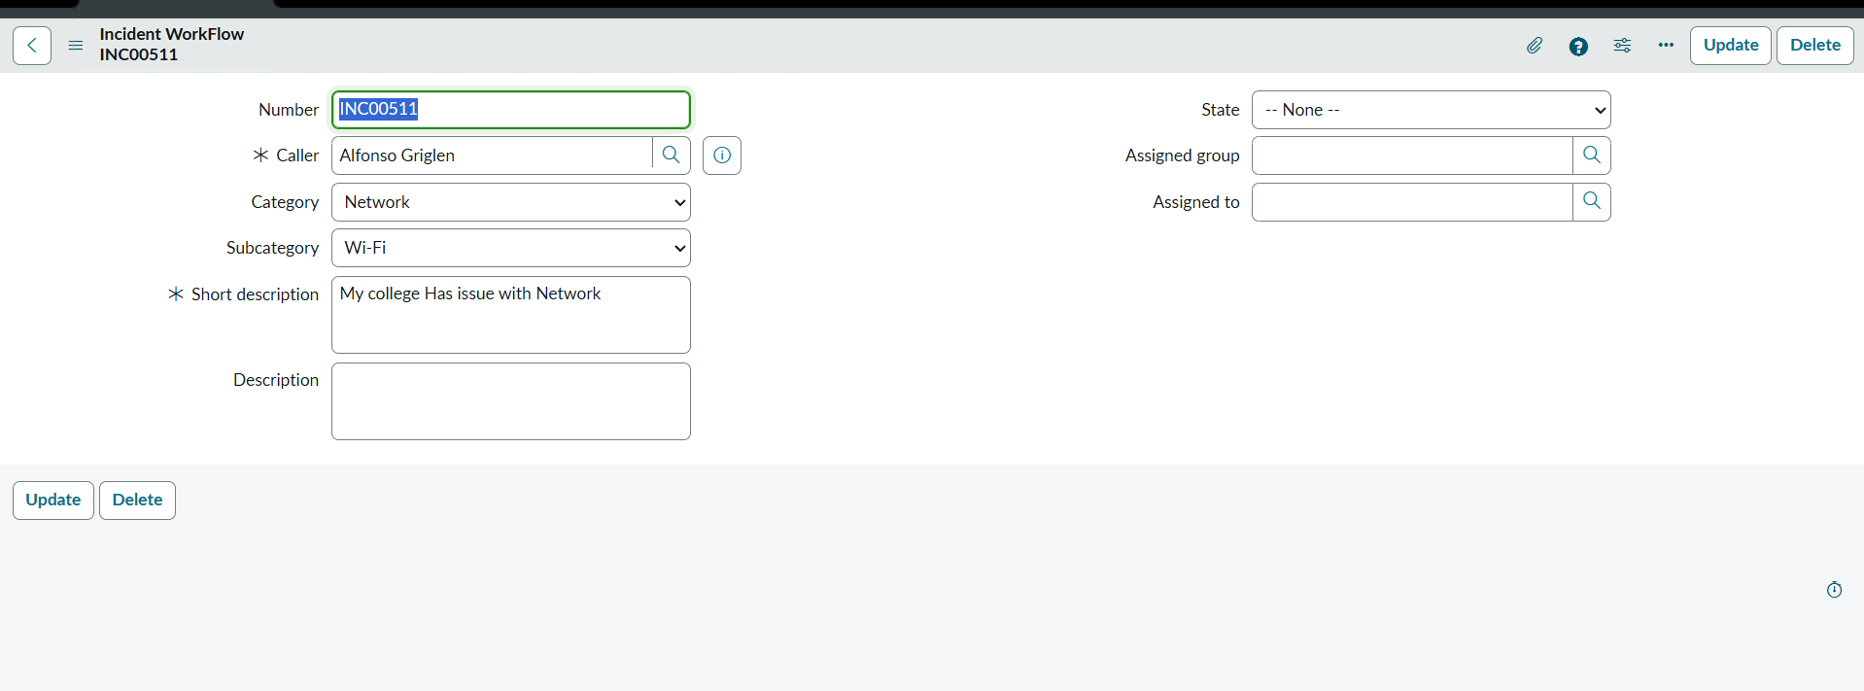
2. | Data Preprocessing | No separate data-preprocessing stage. Flow Designer evaluates the Short Description field directly.
3. | Utilization of Filters | Keyword conditions filter the Short Description for Wi-Fi/Network, Projector, Password/Login, and Slow/Hanging issues.  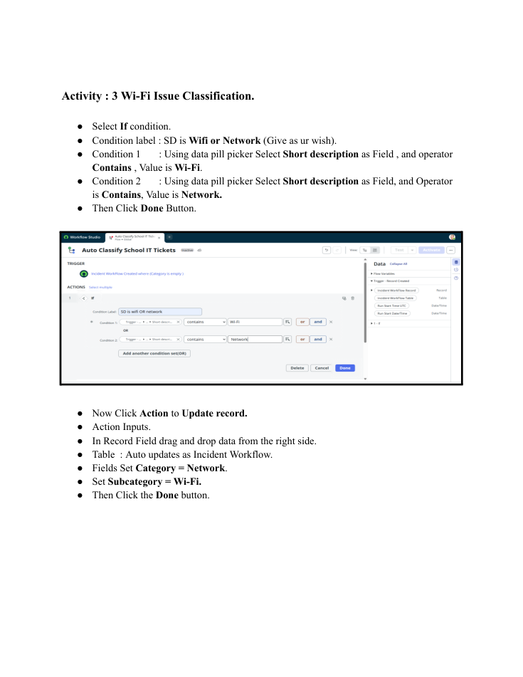
4. | Calculation fields Used | No calculation fields. Classification uses Flow Designer conditions and Update Record actions.
5. | Dashboard design | No dashboard is used. This project is a ServiceNow automation workflow.  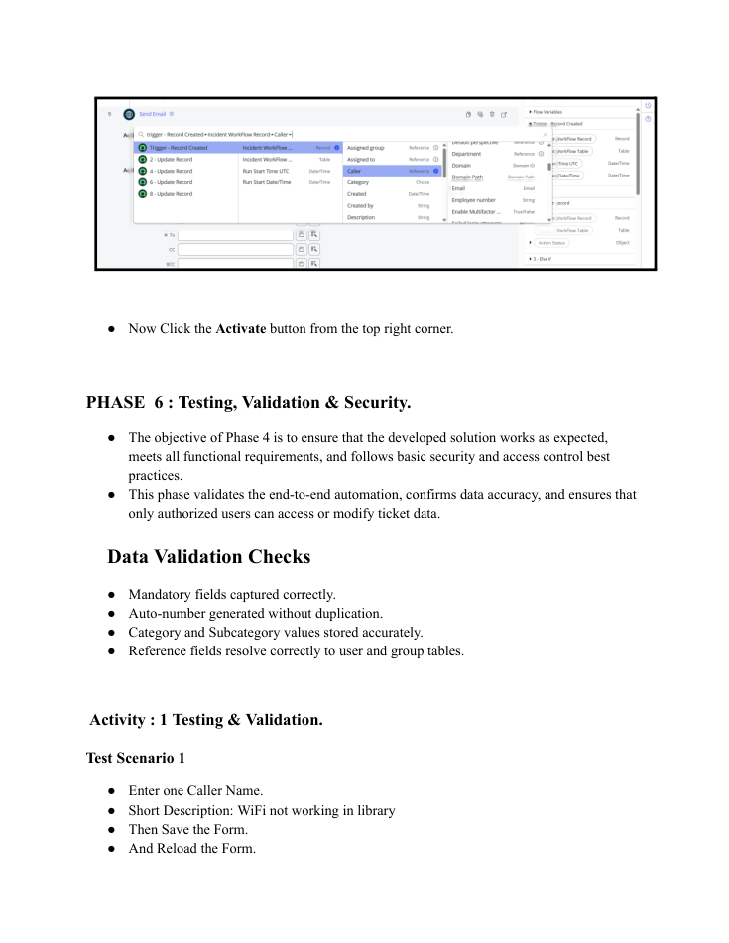
6. | Story Design | No Tableau story is used. The project focuses on automated classification and email notification.

